If you rebuild existing ESXi with in vsan cluster (in Place rebuild in cluster),

Below steps allow you to rebuild host and rejoin to vsan cluster

From working fine Esxi host run below command and not down Sub-Cluster UUID

[root@wcdvhp07h08:~] esxcli vsan cluster get

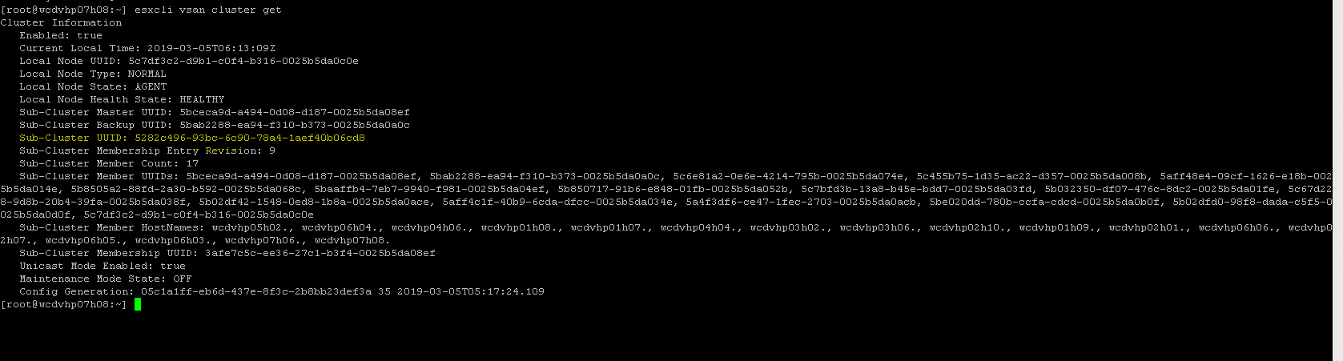

Connect to rebuild done host run this command

Check disk groups available or not (if listing disk groups disk groups are healthy)

Vdq -l

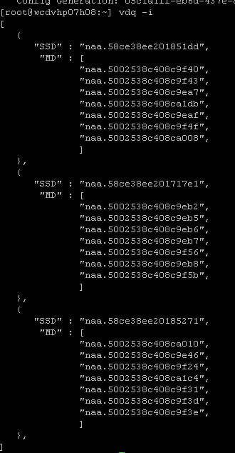

[root@wcdvhp07h08:~]esxcli vsan cluster join -u 5282c496-93bc-6c90-78a4-1aef40b06cd8

After rejoined to vsan run below command to validate

[root@wcdvhp07h08:~] esxcli vsan storage list | grep -i cmmds

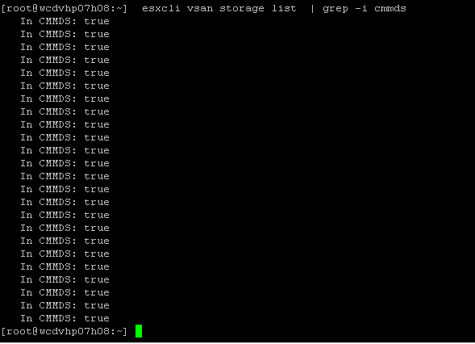

It should come all true. If some comes fail and some are true you have to wait till it comes true

localcli vsan storage list |grep -i 'Device\|In CMMDS\|VSAN UUID\|VSAN Disk Group UUID\|Is Capacity Tier' |sed 'N;N;N;;N;s/\n//g' | sort -k9;

